PERFORMANCE ANALYSIS OF FACEBOOK AD CAMPAIGNS FOR SUPERHERO U:
RECOMMENDATIONS ON WHY SOME ADS CAMPAIGN SHOULD BE DISCONTINUED
PREPARED BY
Bakari TUNGWA
Brian Okoth
SWAHILIPOT HUB FOUNDATION
TECH PROGRAM DEPARTMENT
DATA HUB GROUP
10 MAY 2025

Table of Contents
Table of Contents 2
List of figures 3
CHAPTER ONE: INTRODUCTION 3
METHODOLOGY 3
DATASET OVERVIEW 4
DATA CLEANING 4
EXPLORATORY DATA ANALYSIS 5
CAMPAIGN PERFORMANCE ANALYSIS 5
TOTAL AMOUNT SPENT BY EACH CAMPAIGN 6
AMOUNT SPENT PER CAMPAIGN THROUGH REACH 7
AMOUNT SPENT PER CAMPAIGN VARSES IMPRESSIONS 7
COST PER CLICK FOR EVERY CAMPAIGN 8
COST PER RESULT FOR EACH AD CAMPAIGN 9
RELATIONSHIP BETWEEN THE COST PER CLICK AND THE IMPRESSIONS FOR EACH AD CAMPAIGN 10
RELATIONSHIP BETWEEN THE COST PER CLICK AND THE REACH FOR EACH AD CAMPAIGN 10
RELATIONSHIP BETWEEN THE COST PER RESULT AND THE REACH FOR EACH AD CAMPAIGN 11
CHAPTER TWO: RECOMMENDATIONS AND CONCLUTIONS 11
NTRODUCTION 11
RECOMMENDATIONS 12
CONCLUSIONS 12

List of figures
Fig 1
Fig 2
Fig 3
Fig 4
Fig 5
Fig 6
Fig 7
Fig 8
Fig 9
Fig 10
Fig 11

CHAPTER ONE: INTRODUCTION
The primary objective of this analysis was to identify underperforming ad campaigns from Facebook campaign data and provide actionable recommendations to the marketing team. The end goal is to give insightful reasons on why some ads campaigns should be discontinued.

METHODOLOGY
The dataset used for this analysis was provided by the supervisor and included various campaign performance metrics such as amount spent, impressions, clicks, CTR (Click Through Rate), cost per click, and reach. The following key steps were taken to ensure a structured and meaningful analysis:
Data analysis was performed using python Jupiter notebook and pushed to a GitHub account environment. This can be accessed through the following link
https://colab.research.google.com/drive/1QD3SjkKNf9DLJoOBqXXKHaZo6x49C6V5?usp=sharing

DATASET OVERVIEW
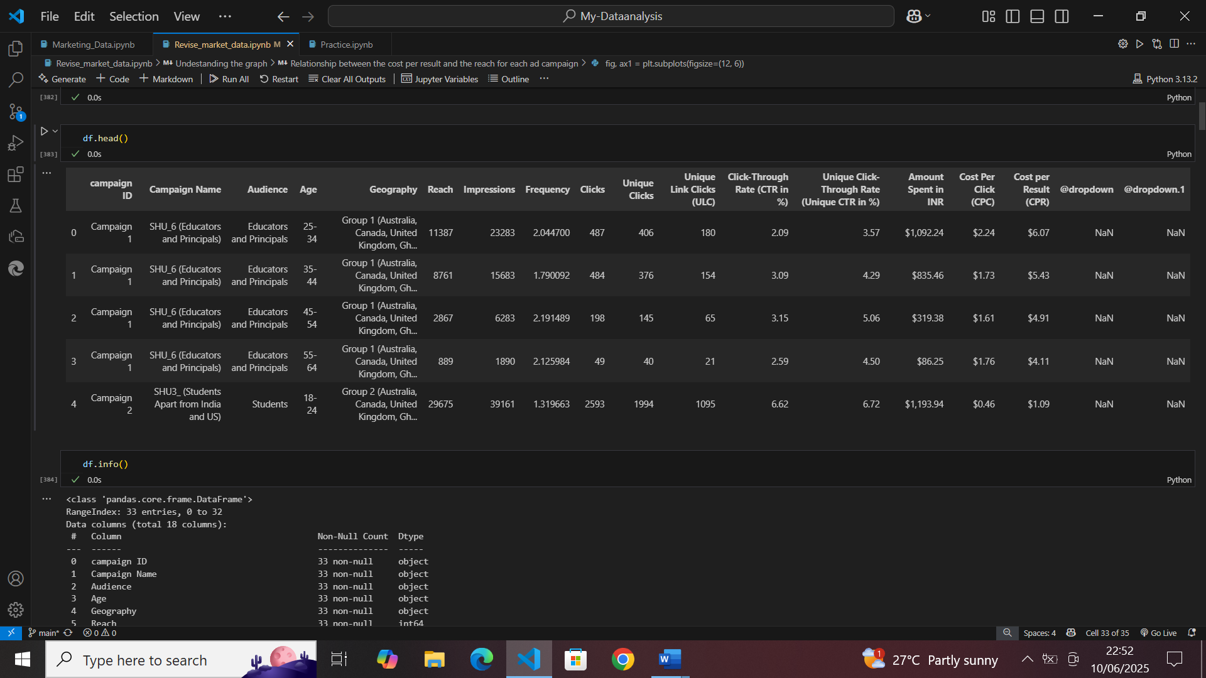
Figure 1:Dataset overview
Total number of variables are 18, number of observations accounts to 33, missing cells are 66 which represent two variables which had no input variable accounting to 11.1%. There are no duplicate rows.
There are 5 categorical variables,8 numerical variables,3 text and 2 unsupported types

DATA CLEANING
The raw dataset was first cleaned by handling missing values, correcting data inconsistencies, and ensuring proper formatting for analysis. This included renaming columns for clarity and converting data types where necessary.
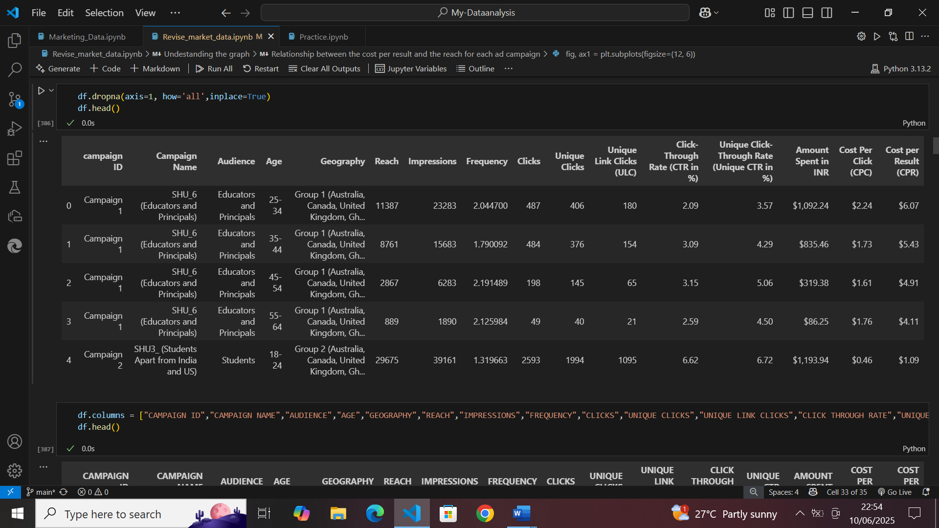
Figure 2:Data cleaning

EXPLORATORY DATA ANALYSIS
First, the data was grouped by campaign name and measures such as amount spent, impressions, clicks, CTR, reach and CPC were aggregated to evaluate campaign-level performance. As a result, we were able to determine which efforts were functioning well and which were not.

CAMPAIGN PERFORMANCE ANALYSIS
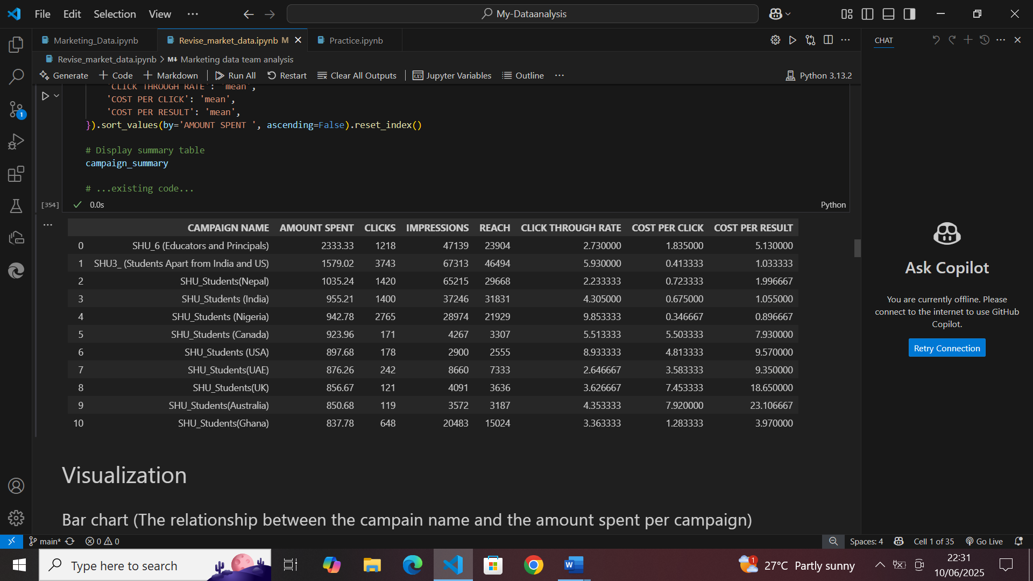
Figure 3: Campaign performance analysis

TOTAL AMOUNT SPENT BY EACH CAMPAIGN
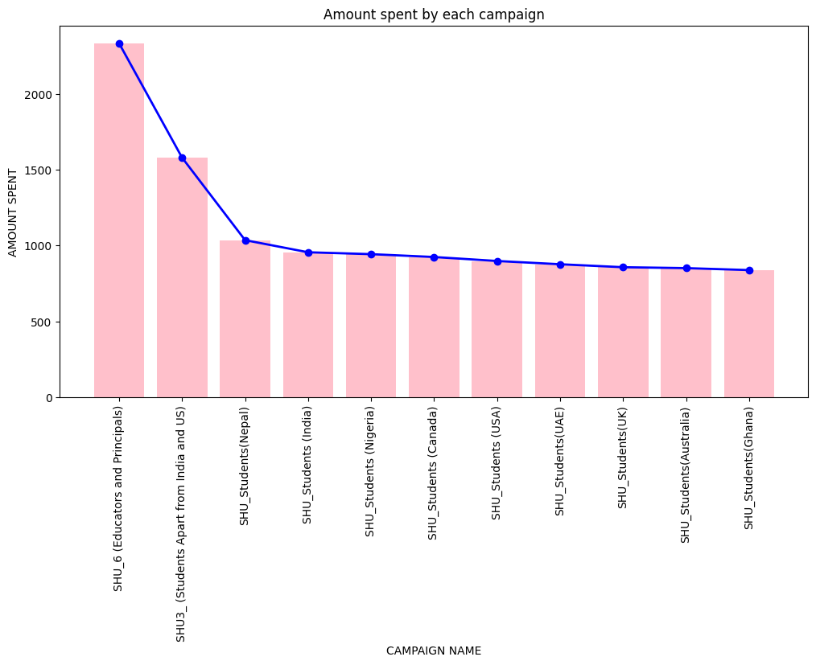
Figure 4:Amount spent by each campaign

AMOUNT SPENT PER CAMPAIGN THROUGH REACH
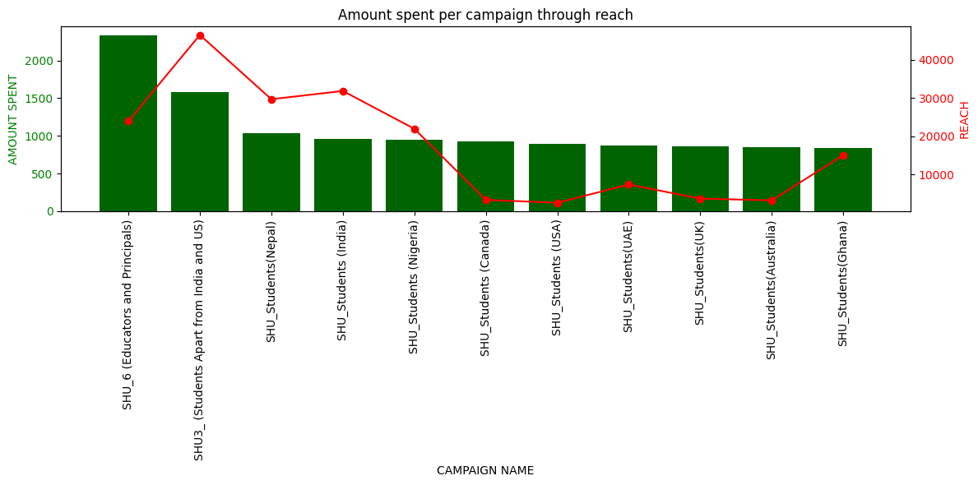
Figure 5: Amount spent per campaign through reach

AMOUNT SPENT PER CAMPAIGN VARSES IMPRESSIONS
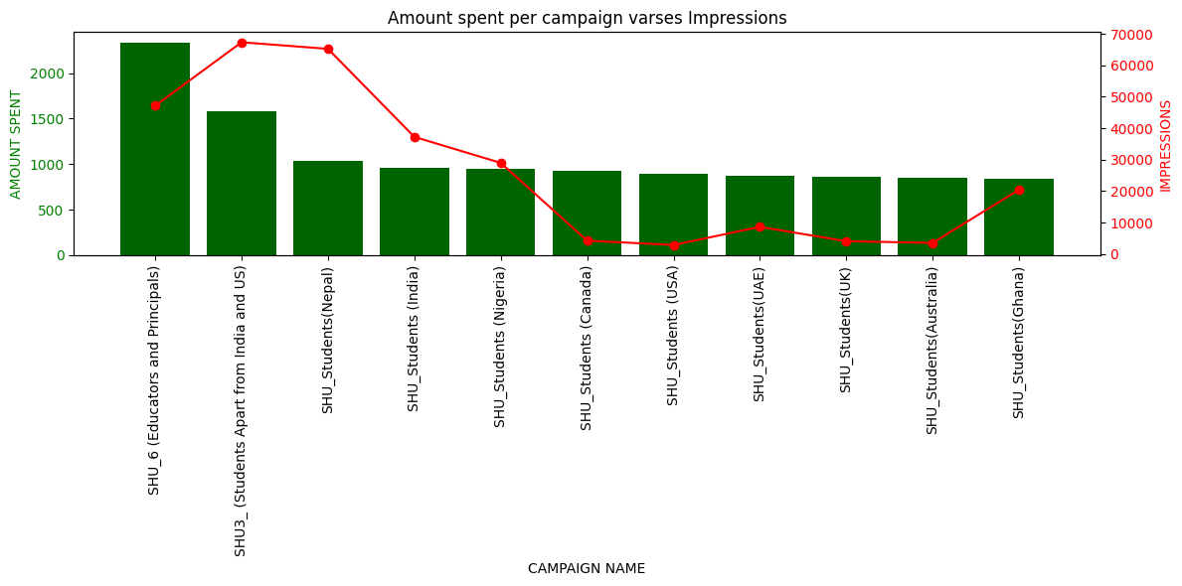
Figure 6:Amount spent per campaign verses impressions

COST PER CLICK FOR EVERY CAMPAIGN
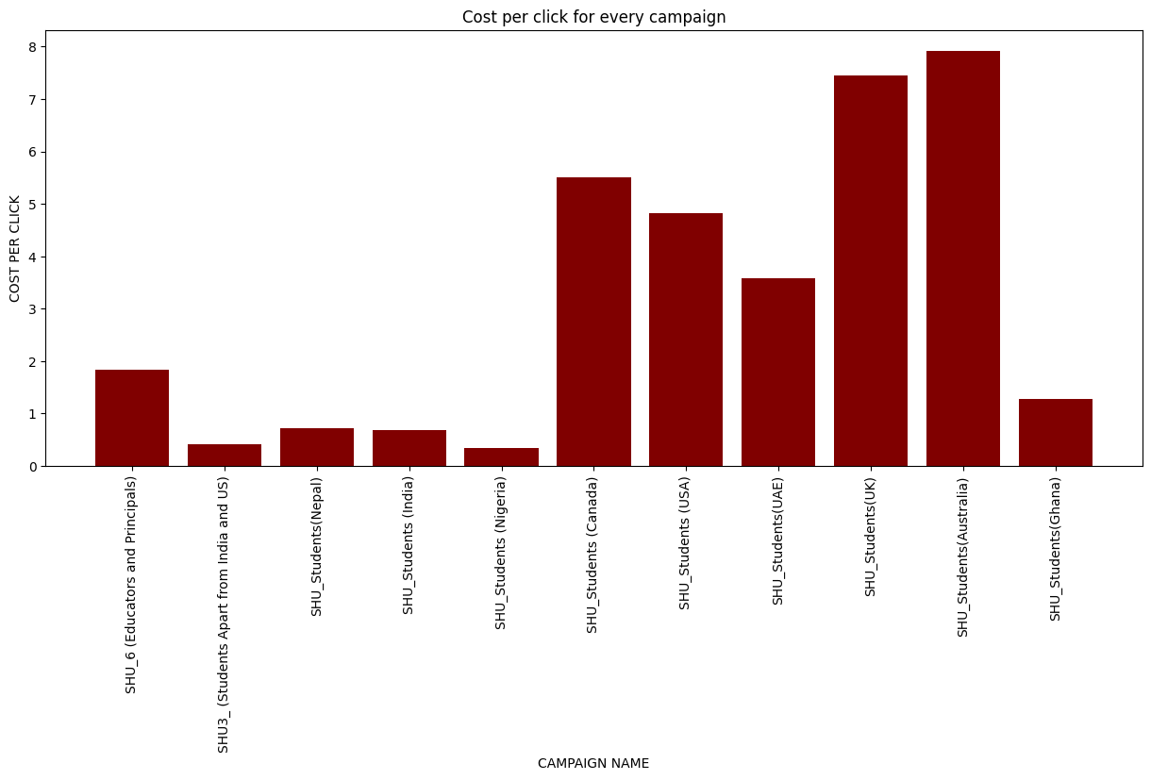
Figure 7: Cost per click for every campaign

COST PER RESULT FOR EACH AD CAMPAIGN
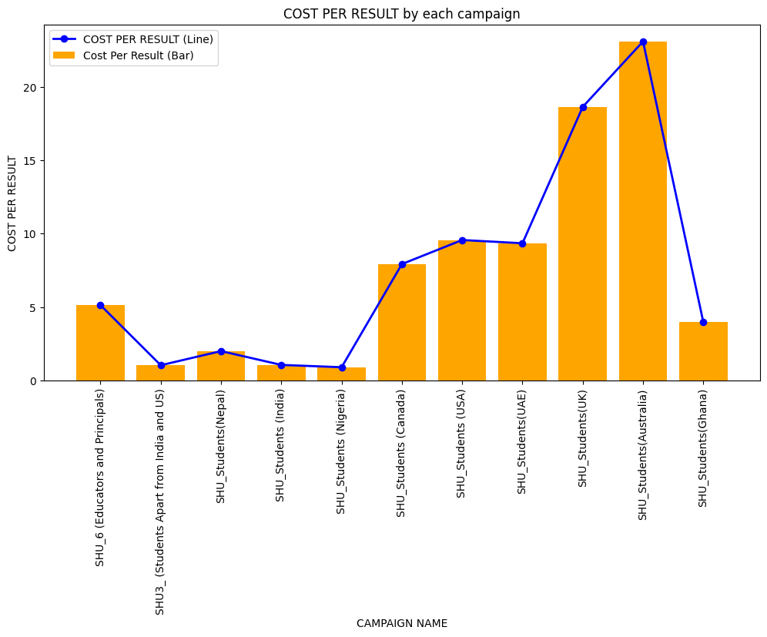
Figure 8:Cost per result for each campaign

RELATIONSHIP BETWEEN THE COST PER CLICK AND THE IMPRESSIONS FOR EACH AD CAMPAIGN
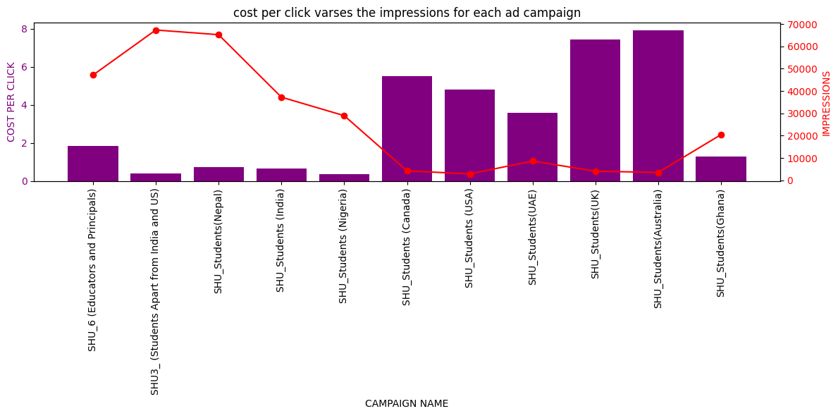
Figure 9:Cost per click vases impressions

RELATIONSHIP BETWEEN THE COST PER CLICK AND THE REACH FOR EACH AD CAMPAIGN
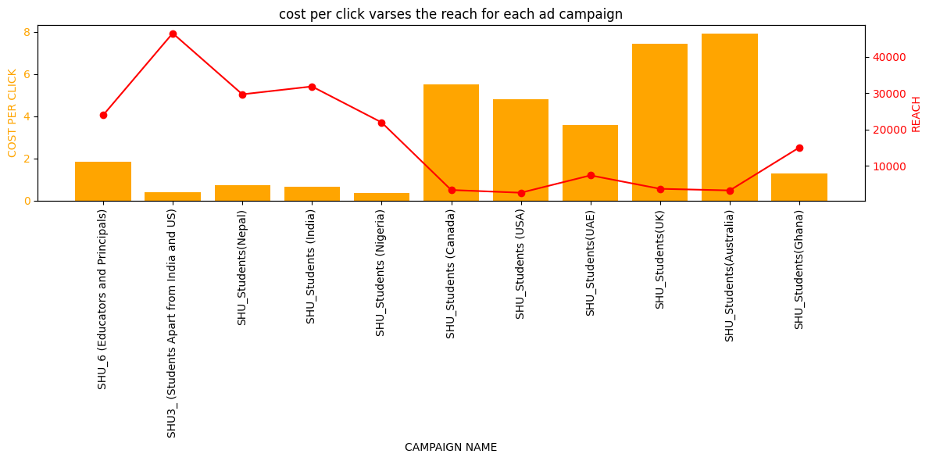
Figure 10:Cost per click vases reach

RELATIONSHIP BETWEEN THE COST PER RESULT AND THE REACH FOR EACH AD CAMPAIGN
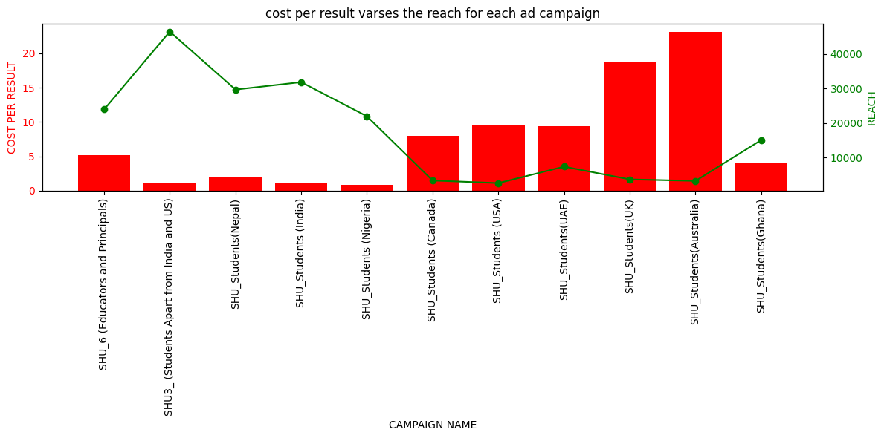
Figure 11:Cost per result vases reach

CHAPTER TWO: RECOMMENDATIONS AND CONCLUTIONS

NTRODUCTION
This chapter outlines the key recommendations and final conclusions derived from the performance analysis of Global Hala’s Facebook ad campaigns for the Superhero U event. Building upon thorough data cleaning, aggregation, and segmentation by campaign name, age group, and geographic location, the analysis identified both high-performing and underperforming segments. The chapter begins by presenting actionable recommendations aimed at optimizing marketing spend by discontinuing ineffective campaigns and redirecting resources toward the most efficient audience segments and regions. These conclusions provide a data-driven foundation for strategic decision-making in future marketing initiatives.

RECOMMENDATIONS
Based on the team analysis, we recommended to discontinue several elements of the current advertising strategy that have proven to be underperforming. Specifically, the campaigns labelled SHU Students (Australia), SHU Students (UK), SHU Students (USA), SHU Students (Canada) have consistently shown low engagement metrics such as reach and impressions with very high cost per click and cost per result, indicating poor performance and inefficient use of the advertising budget.

CONCLUSIONS
The analysis highlights valuable insights into the effectiveness of current ad campaigns. A data driven approach can help optimize marketing spend and increase overall return on investment for future events.
I therefore from those insightful analysis recommends the discontinuity of the above ads’ campaigns.

